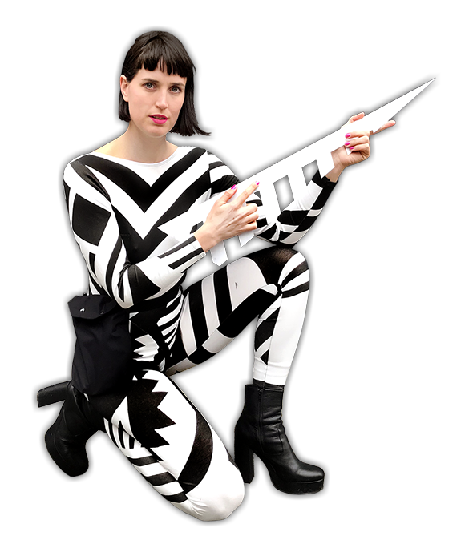
I'm Tessel, some call me Super Tessel. My work crosses the border between costume design and performance. This includes: clothing, props, set design, installation, collaborative workshops and teaching. My practice is split between self-initiated work, commissions and work for hire. I am also part of Questions Collective, a multi-disciplinary collaboration that combines location theater with design, dance and illustration.
In everything I create, I try to make communication physical and give shape to the imaginary. Playing with notions of fantasy and functionality, my work makes dreams wearable. Step inside to find out more about my world!
My self-initiated projects and experiments span costume design, performance, workshops, mixed media installation, film and product design. My work is collaborative and research based, using both form and making as explorative tools of enquiry.
I accept costume making, special prop design and art directing commissions for a wide range of projects. Here you can view a sample of my commissioned projects, which have spanned the realms of film, advertising, exhibitions and theatre.

